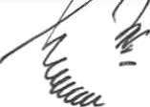
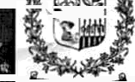
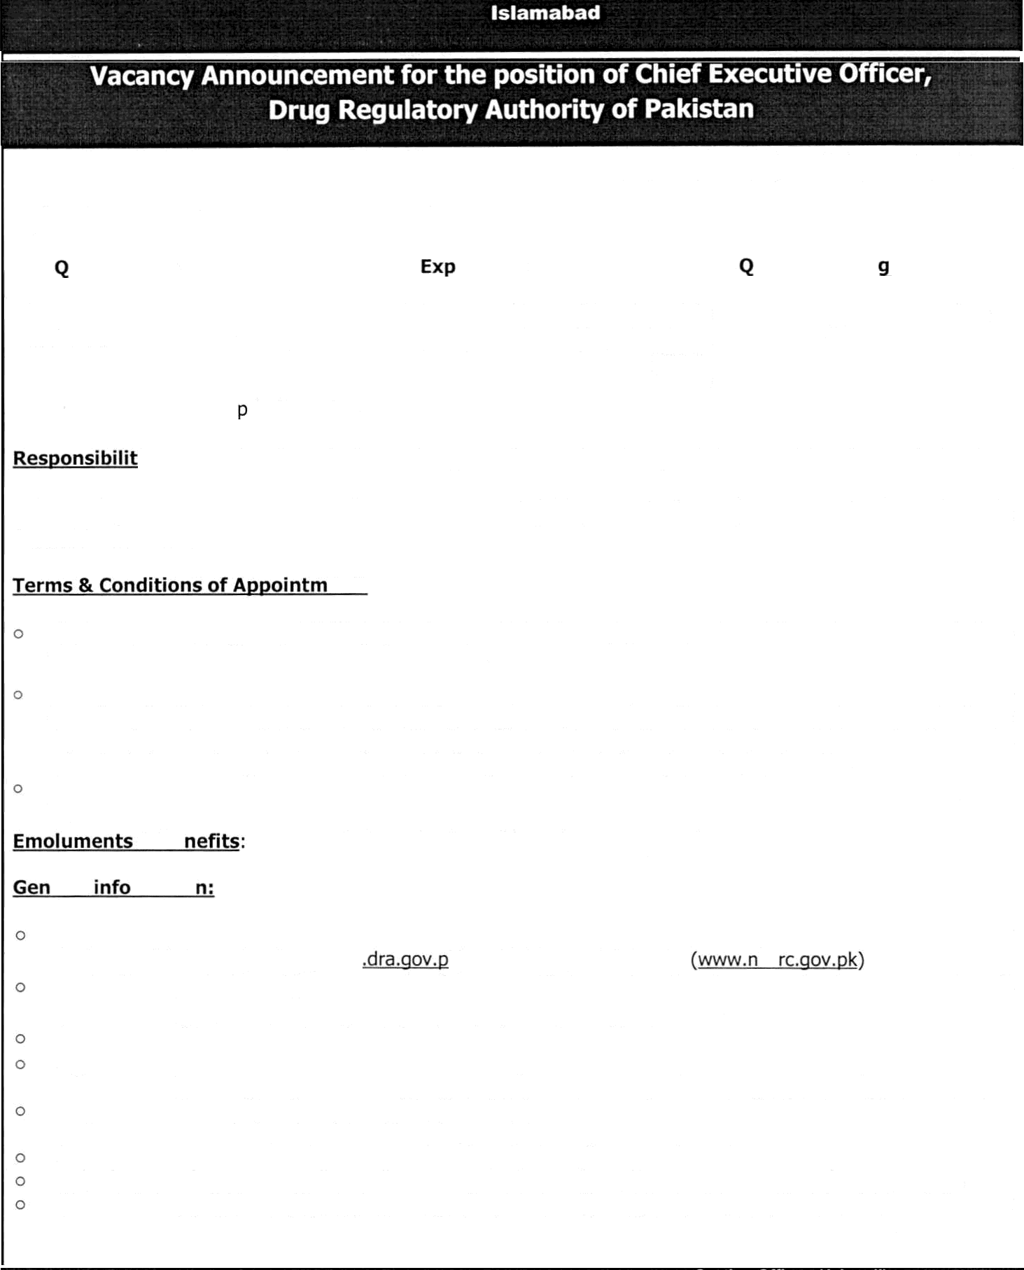
Ministry o
Government of Pakistan
Ministry of National Health Services, Regulation & Coordination
ation Senrice. ns & Coo
rdination,

Applications are invited from the Pakistani nationals to fill the position of the Chief Executive Officer, Drug Regulatory Authority of Pakistan (DRAP) under Section-5 of DRAP Act, 2012. Requisite qualification / experience are as under:-

ualification | erience | uota | A e Limit
Post graduate degree in Pharmacy or medicine. | Minimum of twenty years experience in management or pharmaceutical field or regulatory affairs, in public  sector, or if no such person of aforesaid qualifications is available in the public sector, then a person possessing above qualification and experience from rivate sector. | Merit | Not less than 45  years or more than 56 years
ies: The CEO shall exercise general control and supervision over the affairs of the Drug Regulatory Authority of Pakistan (DRAP) and shall ensure the provisions of the Act (DRAP Act, 2012), the rules and that the regulations, policies and directions of the Board (Policy Board of DRAP) are properly executed or the Federal Government.
ent:
The tenure of appointment of CEO shall be for a period of three (3) years, extendable on the recommendations of the Policy Board of DRAP for one (01) year only.
The incumbent upon appointment shall not have any financial or professional conflict of interest and has no immediate family member (parent, child, sibling or spouse) as senior officials or owner of concerns dealing in therapeutic goods. An affidavit regarding 'Conflict of Interest’ under Section-18 of the DRAP Act, 2012 must be submitted along with application proforma. Similarly, applicant shall not have dual nationality.
Government reserves the right for periodically evaluate performance of the CEO during service tenure against key performance indicators in line with role enshrined in law.
& Be Negotiable at the time of interview or as per rules.
eral rmatio

The prescribed application Form for appointment can be downloaded from the website of Drug Regulatory Authority of Pakistan (DRAP) (www k) and Ministry of NHS,R&C hs
Application should be addressed to the Secretary, Ministry of National Health Services, Regulations & Coordination (NHS,R&C), 3’ d Floor, Kohsar Block, Pak. Secretariat, Islamabad.
No person shall be appointed as the CEO unless he is a citizen of Pakistan.
Application should reach in the office of the undersigned within 15 days from the date of publication of the advertisement.
Incomplete without affidavit regarding "Conflict of Interest” under Section-18 of DRAP Act, 2012, application proforma or received after due date will not be entertained.
Applicants / candidates already in service should apply through proper channel.
Only short listed candidates will be called for interview and No TA/DA shall be admissible for the purpose.
Short listed candidates will present degrees/certificates (in original) duly verified by Higher Education Commission of Pakistan (HEC) at the time of interview otherwise will be disqualified for interview.

Section Officer (Admn-ll)
M/o National Health Services Regulations & Coordination,
3^ Floor, Kohsar Block, Pak, Secretariat, Islamabad

APPLICATION FORM

Name of most: Chief Executive Officer (CEG), DRAP
Name of Applicant: Father’s Name: Date of Birth: Age (on closing date): C.N.I.C No: Domicile: District: Nationality: whether dual Nationalit y: Yes/No
Tn ough proper Chaar,ei Yes / NG. iYame o? ñepartrnec,t:
Postal Address of Candidate: Permanent Address of Caddidate: Phone No: Mobile No: Email Address: ACADEMIC QUALIFICATION:
Certificate /  Degree | Year of Passing | Board / University | Division /  Grade | Name of Institution
TECHNICAL / PROFESSIONAL QUALIFICATION:

EXPERIENCE:

Name of Public  Organization | Post Held | From | To | Total year(s) / month(s)

Name of Private Organization | Post Held | From | To | Total year(sj /  month(s)
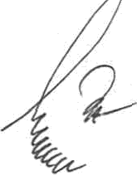
P.T.0

Thank you for using www.freepdfconvert.com service!

Only two pages are converted. Please Sign Up to convert all pages. https://www.freepdfconvert.com/membership

